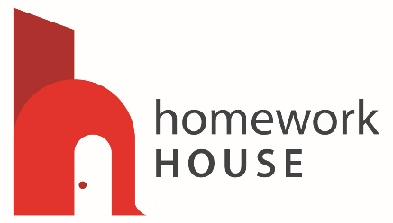
Homework House
54 North Summer St.
Holyoke, MA 01040
413-265-1017
homeworkhouseholyoke.org
__________________________________________________________________________________

Criminal Records Information (CORI)
Acknowledgement Form

Homework House is registered under the provisions of M.G.L. c.6, ss172 to receive CORI for the purpose of screening current and otherwise qualified prospective employees, subcontractors and volunteers.

As a prospective or current employee, subcontractor or volunteer, I understand that a CORI check will be submitted for my personal information to the DCJIS. I hereby acknowledge and provide permission to Homework House to submit a CORI check for my information to the DCJIS. This authorization is valid for one year from the date of my signature. I may withdraw this authorization at any time by providing Homework House with written notice of my intent to withdraw consent to a CORI check.

I also understand the Homework House may conduct subsequent CORI checks within one year of the date the form was signed by me.

By signing below, I provide my consent to a CORI check and affirm that the information provided on page 2 of this Acknowledgment Form is true and accurate.

________________________________________ _______________________
Signature of CORI subject Date

